WALKING STICK

User Manual

1. Parts of the Walking stick
2. How to Walk with the Walker Methods of the Usage and Operation.
3.Tips and Warnings

Walking stick
(DY059201L series, DY05927L series ,DY05910L, DY05920L, DY059201LB, DY05927LB, DY05939L, DY05929L, DY05930L, DY05928L, DY05938LB, DY05921,DY05922,DY05924,DY05926,DY05932, DY05934, DY05931,DY05941,DY05923L)
1. Parts of the Walking Stick
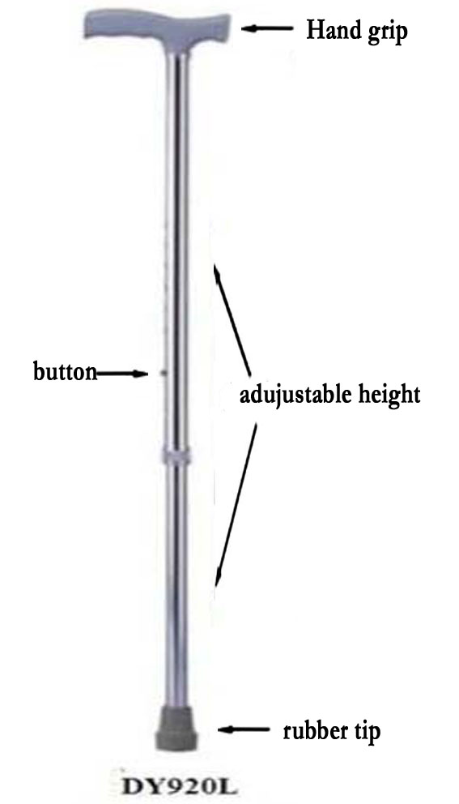
- Methods of the Usage and Operation
(1). Using your cane to get into a chair:
  - Stand with the back of your legs against the chair seat.
  - Rest the cane against the chair.
  - Reach back with both hands to grip the chair arms.
  - Put your weaker leg slightly off the floor.
  - Put all your weight on your stronger leg.
  - Slowly sit down and slide backwards into the chair.

(2). Using your cane to get out of a chair:
- Hold your cane with your stronger hand.
- Grasp the arms of the chair.
- Put your stronger foot a little forward.

(3). Home Care Using a Cane to Get Out of a Chair
- Pictures of a man using a cane to get out of a chair
- Lean a little forward and push on the arms of the chair to raise yourself.
- Stand with your cane about 4 inches (10 cm) to the side of your stronger foot.
- Wait a few seconds to get used to standing before you start walking.
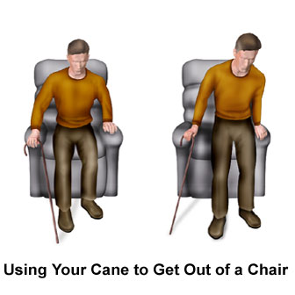
(4). Using your cane to walk on flat floors:
- Picture of a man with a cane and cane placement steps
- Using the cane to help keep your weight off your weaker leg, move your stronger leg ahead.
- Your heel will be a little beyond the tip of the cane.
- Repeat these steps and try to walk straight.
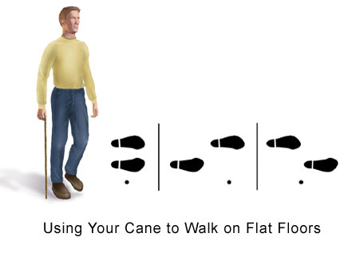

(5). Using your cane on stairs:
- To climb stairs, grasp the handrail (if possible) and step up on your good leg first, with your cane in the hand opposite the injured leg. Then step up on the injured leg.
- To come down stairs, put your cane on the step first, then your injured leg, and finally the good leg, which carries your body weight.
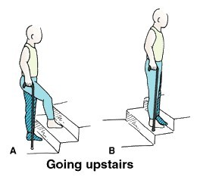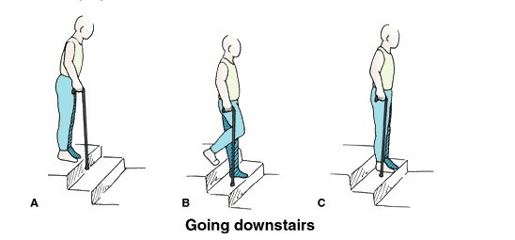
- Tips and Warnings
- Wear shoes with rubber soles, such as tennis shoes. Slippers should not be worn because they can slide off your feet and cause a fall. Do not wear shoes with leather heels or soles that may slide and cause you to fall.
- Check the floor to be sure it is safe for using the cane. The floor must be clean, dry, and well lit. Remove throw rugs to prevent falls. Tape or nail down loose carpet edges. Keep the traffic areas and the floor free of clutter.
- Stand a few seconds before you start moving with your cane. This will get your body used to standing. Do not start walking if you are dizzy.
- Look straight ahead when you are walking. You may run into or trip over something if you are looking at your feet.
- To carry light things while using your cane, use a backpack or carry a bag. Do not try to carry heavy things.

